Chapter 5 Morphology Of Flowering Plants
Morphology is the branch of biology that deals with the study of external features like form, size, colour, structure and relative position of various parts of organisms.

Morphology is essential for recognition or identification of plants, gives information about the range of variations found in a species, deficiency and toxicity symptoms in response to shortage or excess of minerals.

Root system: The underground parts of plant
Shoot system: The portion above the ground (like stem, branches, branchlets, leaves, flower and fruits.
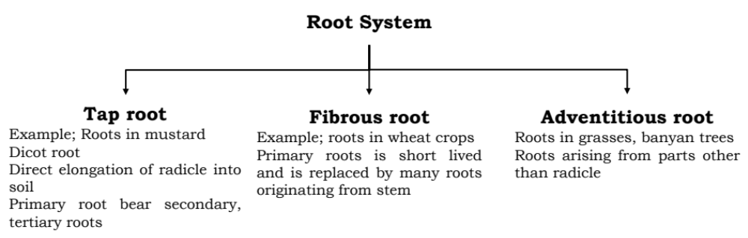
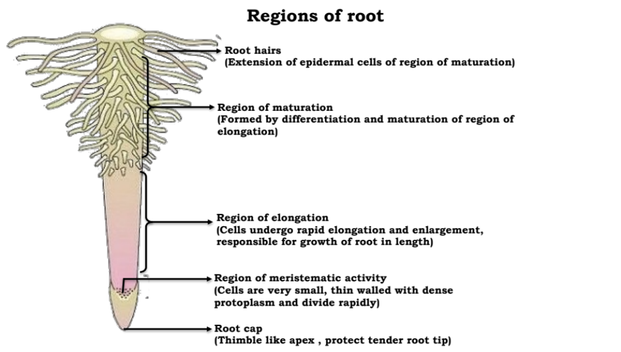
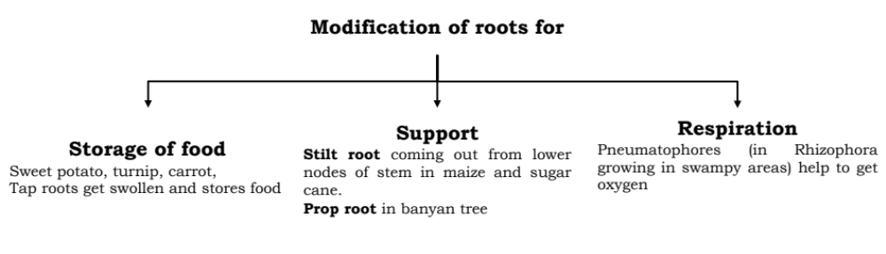

Functions of root
- Absorption of water and minerals from soil
- Providing proper anchorage to the plant parts
- Storing reserve food materials.
- Synthesis of growth regulators
- Pneumatophores in rhizophora helps in respiration

Stem
- The ascending part of axis
- Bears branches, nodes (region of stem where buds are born), internodes (portion between two nodes), leaves, buds, flowers and fruits.
- Developed from Plumule of the embryo.
- Stems are modified to perform different functions.

Functions of Stem
- Spreading branches, bearing leaves, flowers and fruits
- Conducts water and minerals from root to leaves and product of photosynthesis.
- Some stem perform special functions like storage of food, support, protection and vegetative propagation.

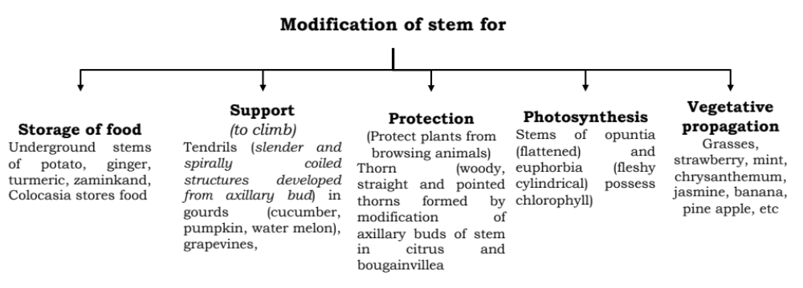
The Leaf (Most important vegetative organ for photosynthesis)
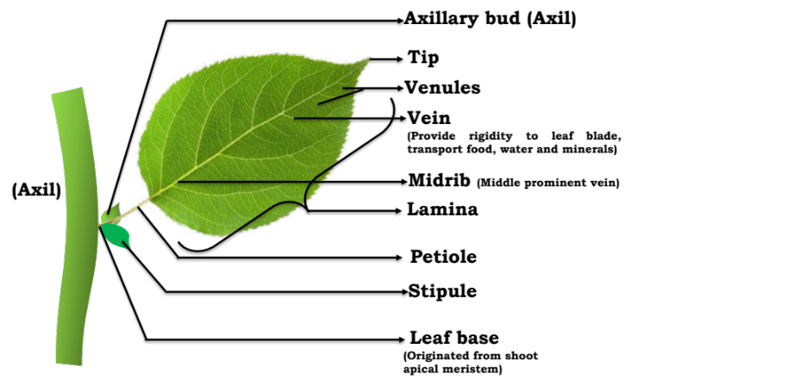
- Leaf is a green, dissimilar exogenous lateral flattened outgrowth which is borne on the node of a stem or its branches is specialized to perform photosynthesis.
- Leaves originate from shoot apical meristem and are arranged in an acropetal order.
- A typical leaf consists of three parts -Leaf base, Petiole, Lamina.
- Leaf is attached with stem by Leaf base which may bear stipule (two small leaf like structure).
- Middle prominent vein is called mid vein.
- Veins provide rigidity to the leaf blade and act as channel for transport of water and minerals.

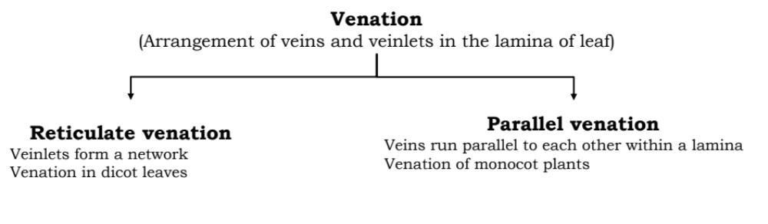
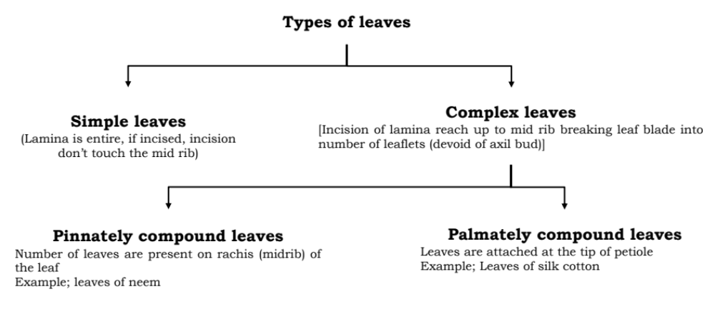
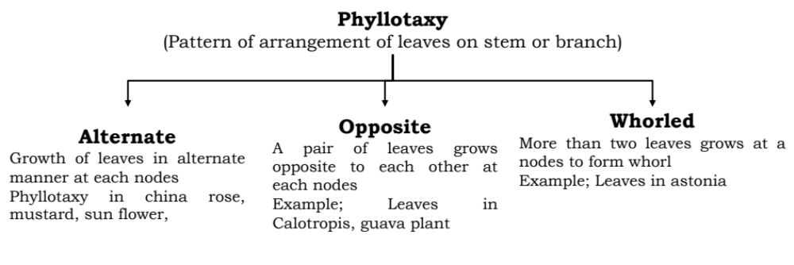

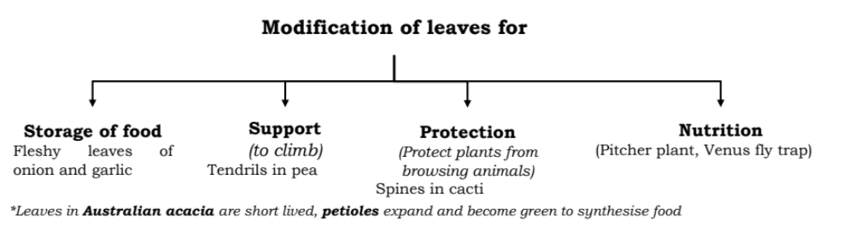

The Inflorescence (Arrangement of flowers in floral axis)
- Born by differentiation of shoot apical meristem
- Bracts: Reduced leaf found at the base of pedicel of flower.
- Flower may be bracteate (present bracts) or ebracteate (absent bracts)

Perianth: Calyx and corolla are not distinct (assembly of tepal)
Staminode: Sterile stamen
Pistillode: A sterile vestigial pistil remaining

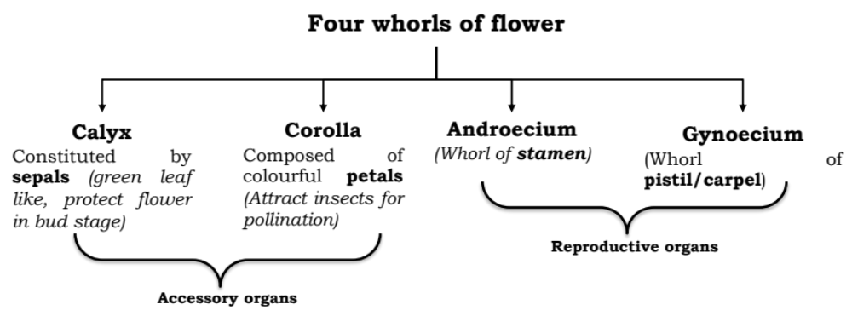
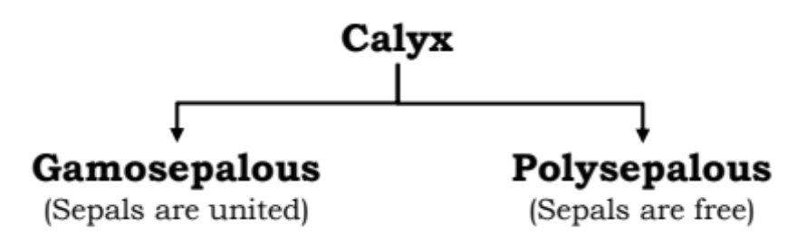
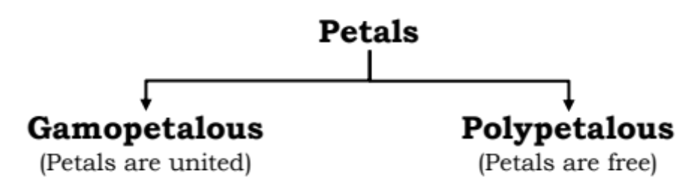
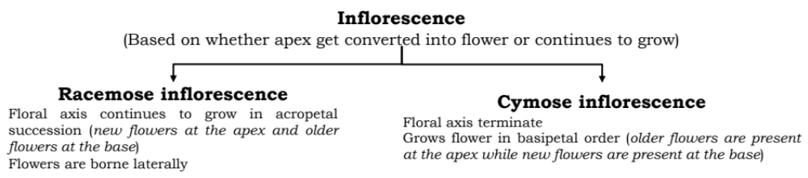
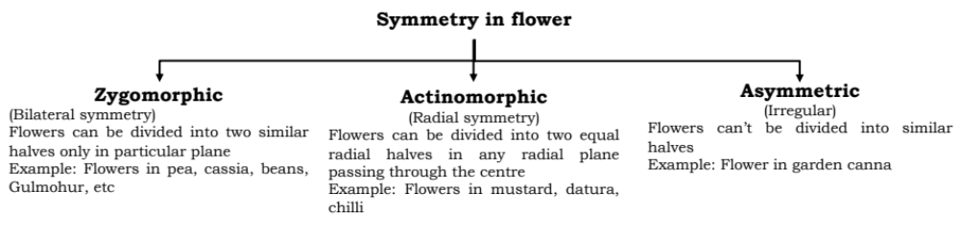
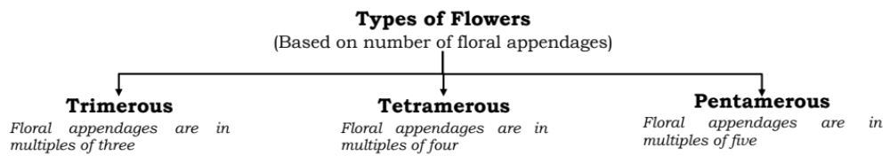
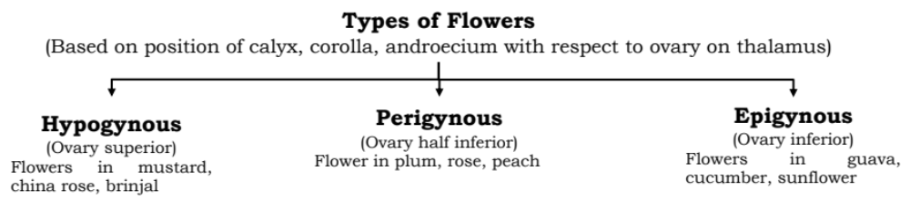
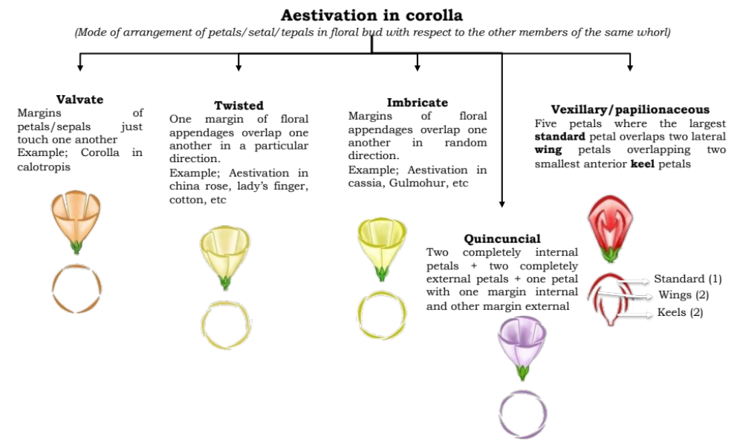

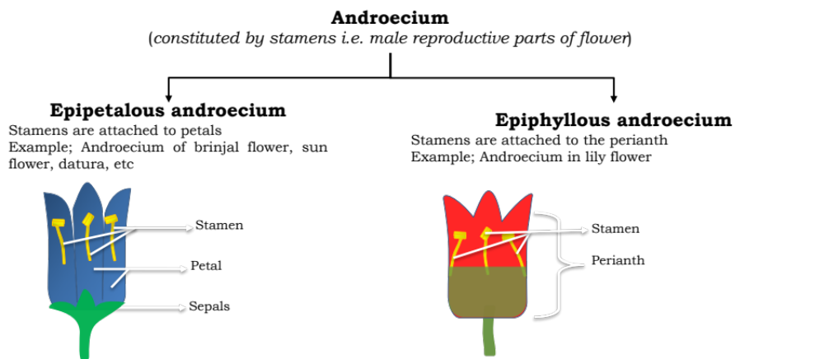
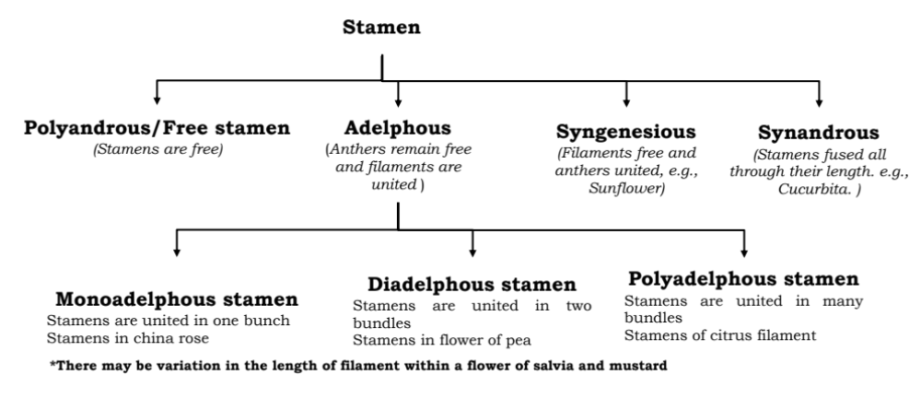
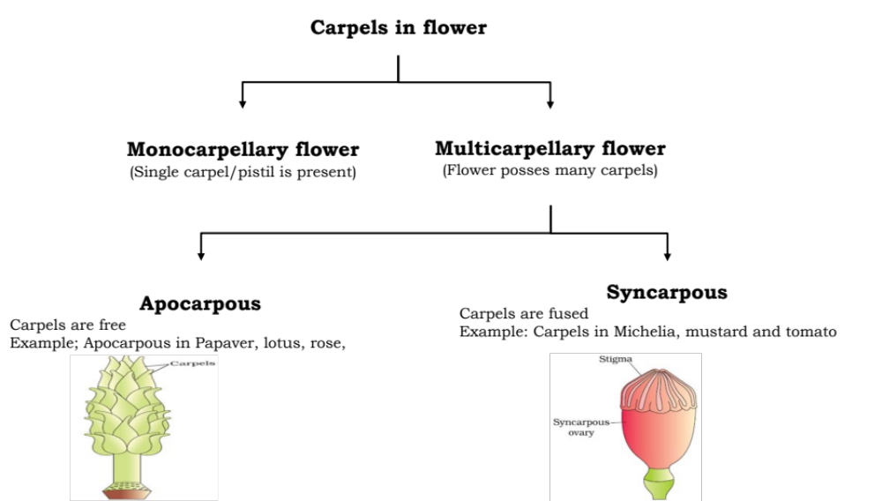
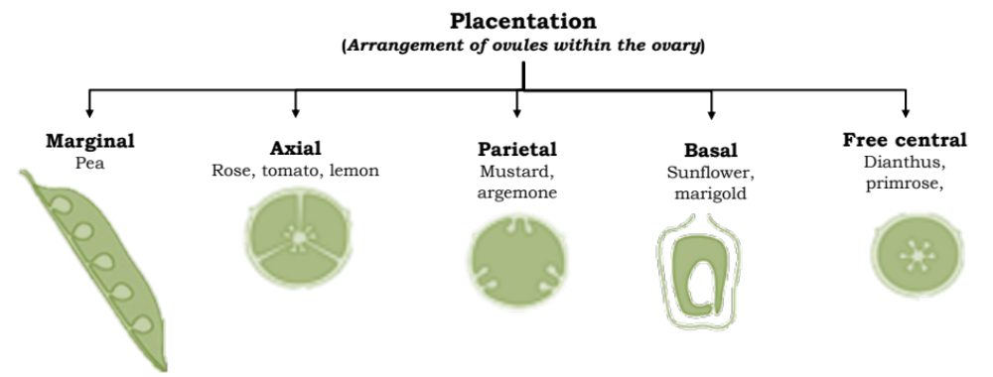

Seed (fertilised ovule)
- Seed is the final product of sexual reproduction in angiosperms.
- Formed inside fruits inside flowering plants
- Seed = seed coat + embryo
- Embryo = Radicle + Plumule + cotyledon(s) + an embryo axis
- Seed coat = Outer testa + Inner tegmen
- The persistent remnants/residuals of nucellus present in seeds are called perisperm. E.g., black pepper and beet
- Seed dormancy is the resting phase (inactive period) of seed during which there is an innate inhibition of germination of a viable seed.
- Dormant seed germinate if favourable conditions are available (adequate moisture, oxygen and suitable temperature).
- Economically, seed dormancy is crucial for storage of seeds
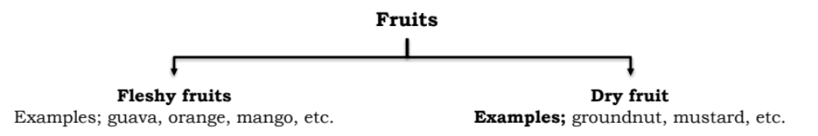
The Fruit
Fruit if mature or ripened ovary
Fruit = Seed + Pericarp
